**Enterprise Resource Planning**

*Of*

**ZAB**

**Training User Manual**

**(SV–12.3.1 | MV–1.0.0)**

**For**

**Intercontinental Dhaka**

**Roster Setup & Update**

**Index**

|  |  |  |
| --- | --- | --- |
| **Option No.** | **Option Name** | **Page No.** |
|  | Roster Entry | **03** |
|  | Roster Update | **10** |

# Roster Entry

|  |  |
| --- | --- |
| **Step 1** | Open System **> Attendance Information >> Roster Entry** |

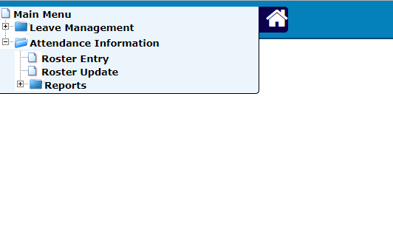

|  |  |
| --- | --- |
| **Step 1** | Open System **> Attendance Information >> Roster Entry** |
| **Step 2** | Assign Start Date & End date for the roster. |
| **Step 3** | Select Department Name and then Select Section ID  (You must select at first **Department Name** to select Section ID) |
| **Step 4** | Select Day Off if required. |
| **Step 5** | Click **Add** |
| **Result** | A new roster will be added |

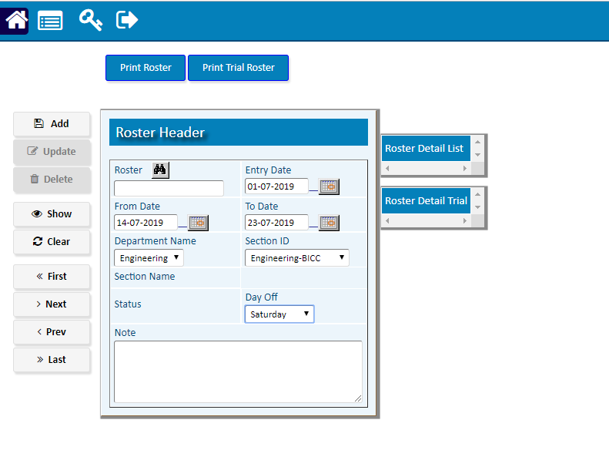

After **Add** roster a new Roster ID will be added >>

1. For trial, click **Trail Run**
2. Click **Print Trial Roster**  to see the Trial Roster

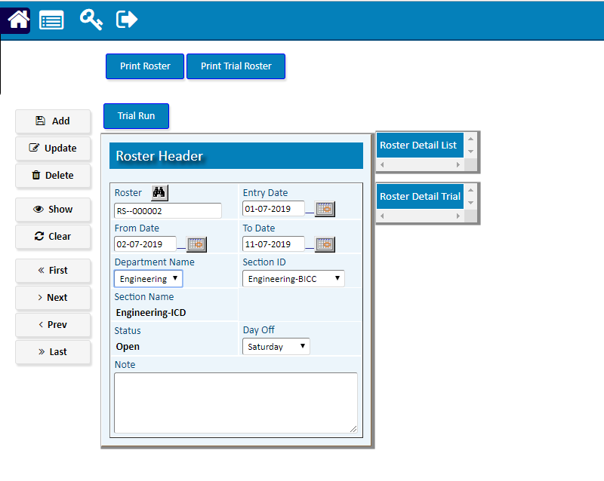

After **Trial Run**, Click **Show** >> (Before going to Roster Detail, You must click **Show**)

1. Click **Detail**

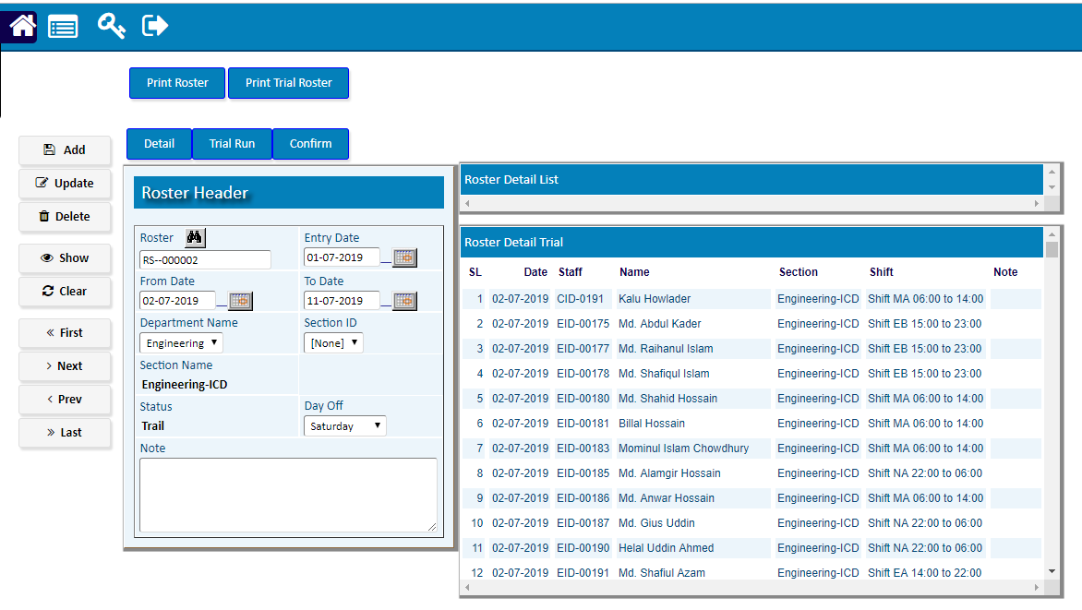

Going Detail >>

1. Pick a staff record from the side list to modify shift.
2. Select the desired shift and then click **Update**

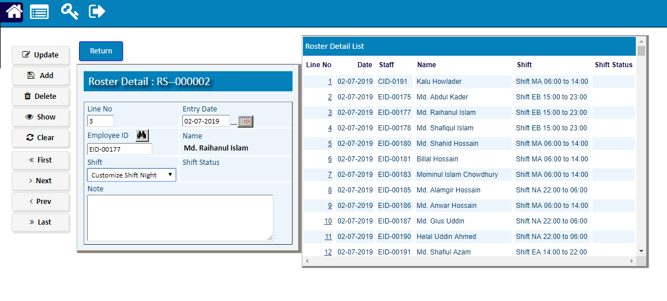

1. **Choose the blank shift to Modify Shift Status**

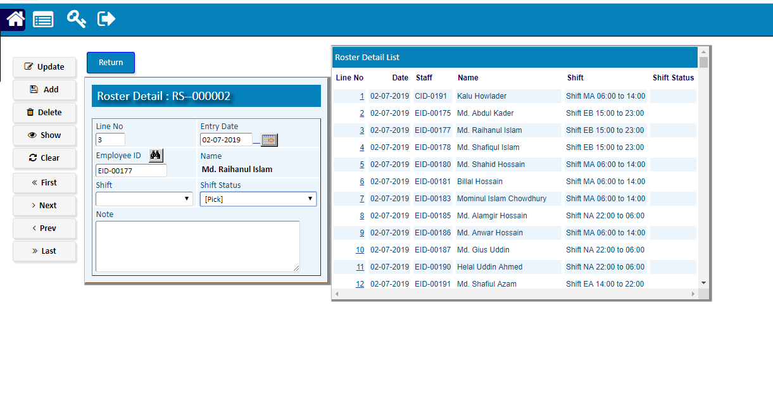

Click **Return** after completing Detail Update.

After return Click **Confirm** to confirm the roster (To show roster click **Print Roster**)

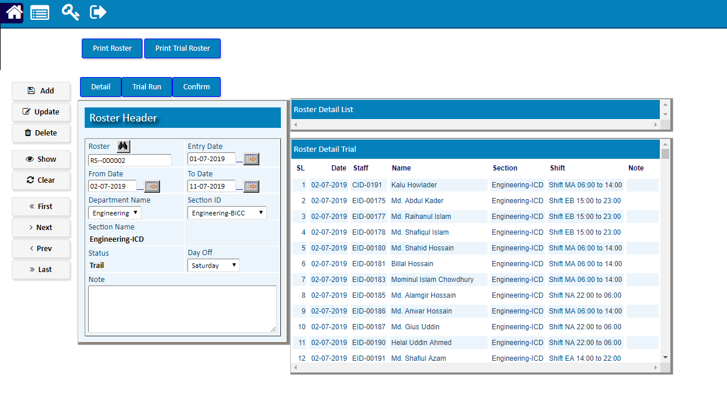

# Roster Update

|  |  |
| --- | --- |
| **Step 1** | Open System **> Attendance Information >> Roster Update** |



|  |  |
| --- | --- |
| **Step 1** | Open System **> Attendance Information >> Roster Update** |
| **Step 2** | Select Section & Date. |
| **Step 3** | Click **Show** |
| **Step 4** | Click **Detail** |

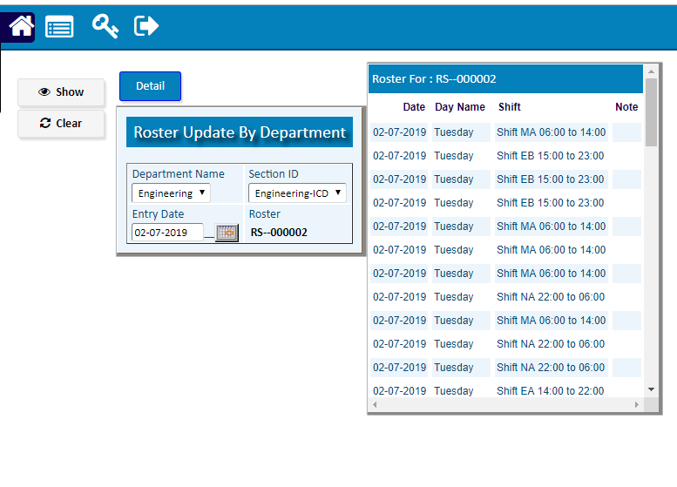

Going Detail >>

1. Pick a staff record from the side list to modify shift.
2. Select the desired shift and then click **Update**



1. **Choose the blank shift to Modify Shift Status**



Click **Return** after completing Update.